22-11-2021 ML SPOT – 12 2019103573

1. Implementation of ID3 algorithm using iris dataset and the parameter for attribute selection is set to Gini index.

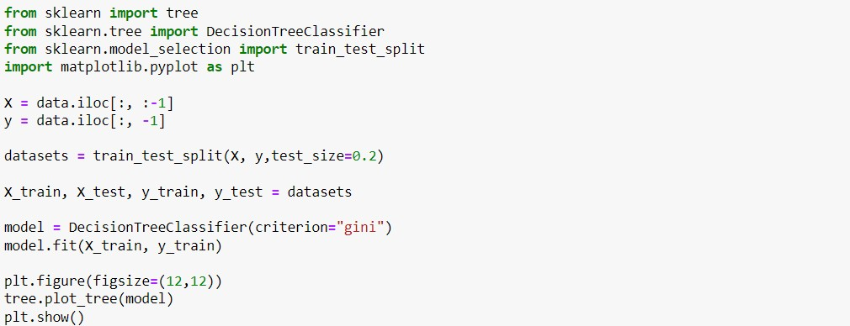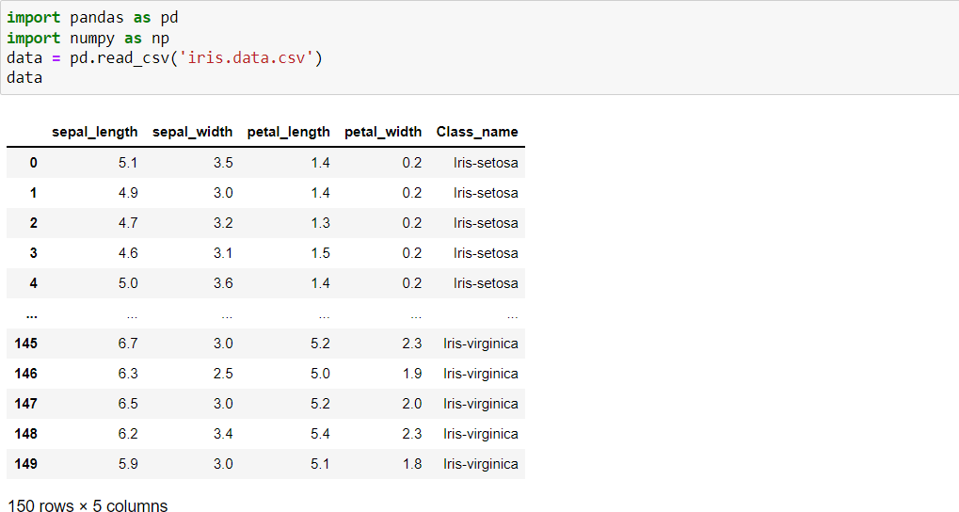

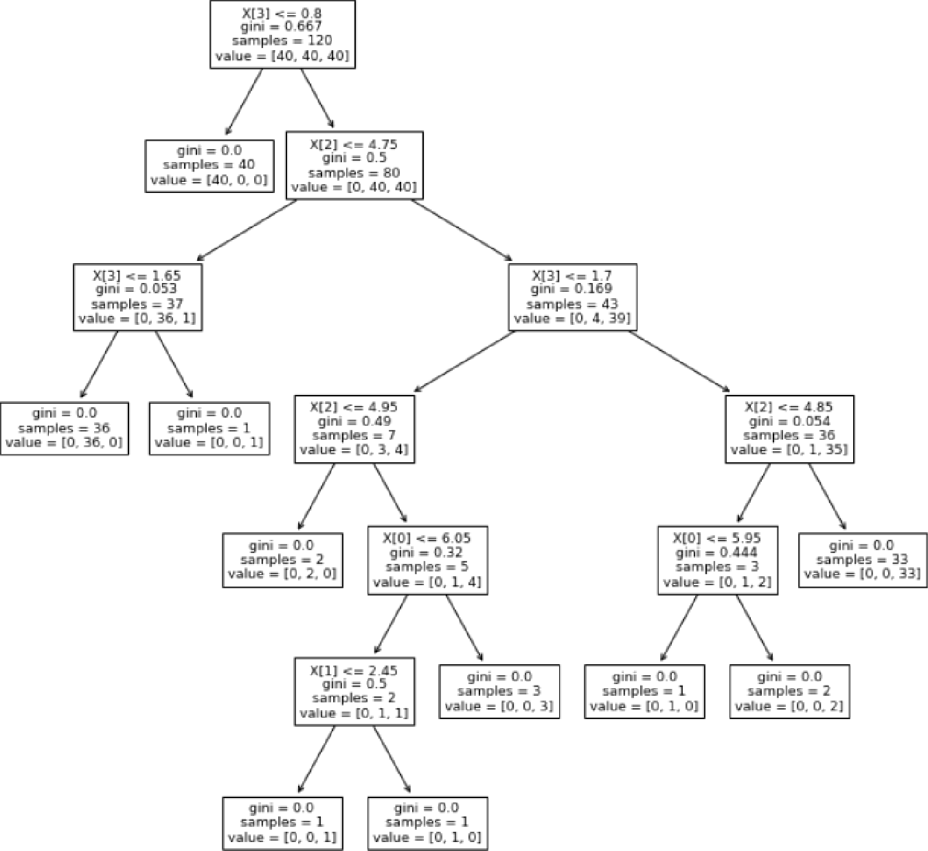

y pred = model.predict(X_test)

from sklearn.metrics import confusion matrix from sk1earn.metrics impoM classification report

{rom sklearn.metrics import accuracy score y true = y test

priut(’Accuracy : ',accuracy scOre(y pred, y test)) print(’\nConfusion Matrix: \n', confusion matrix(y true, y pred))

matrix = classification report(y_true,y pred) print(’\nClassification report : \n’,matrix)

Accuracy : 0. 9666666666666667

Confusion Matrix:

ClassifICatiDn report ’

|  |  |  |  |  |
| --- | --- | --- | --- | --- |
|  | precision | recall | f1—score | support |
| Iris-setDsa | 1.00 |  | 1.00 | 10 |
| Iris—versicolor | 1.00 | 0.90 | 0.95 | 10 |
| Iris-virginica | 0.91 | 1.00 | 0.95 | 10 |
| accuracy |  |  | 0.97 | 30 |
| macro avg | 0.97 | 0.97 | 0.97 | 30 |
| weighted avg | 0.97 | 8.97 | 0.97 | 30 |

# 2. Implementation of ID3 algorithm using party dataset and the parameter for attribute selection is set to Gini index.

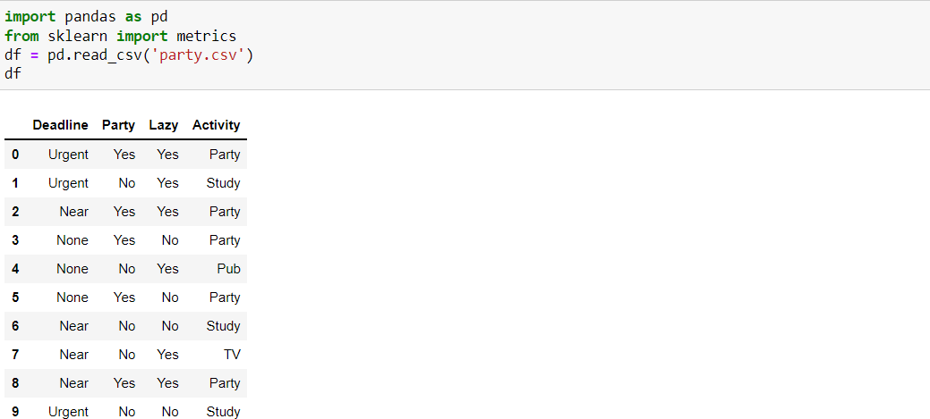

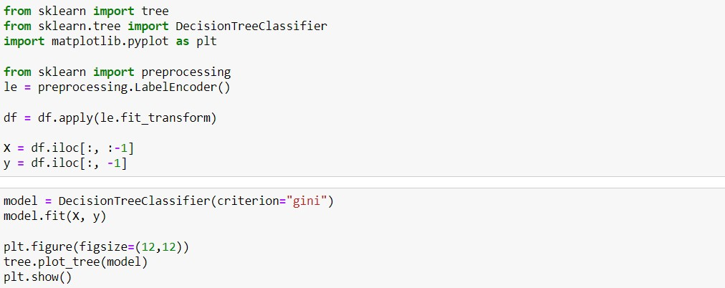

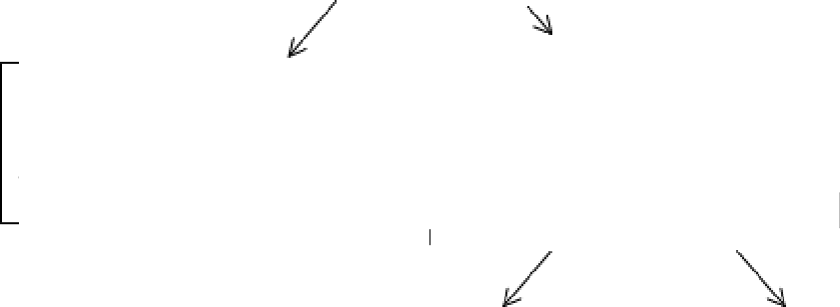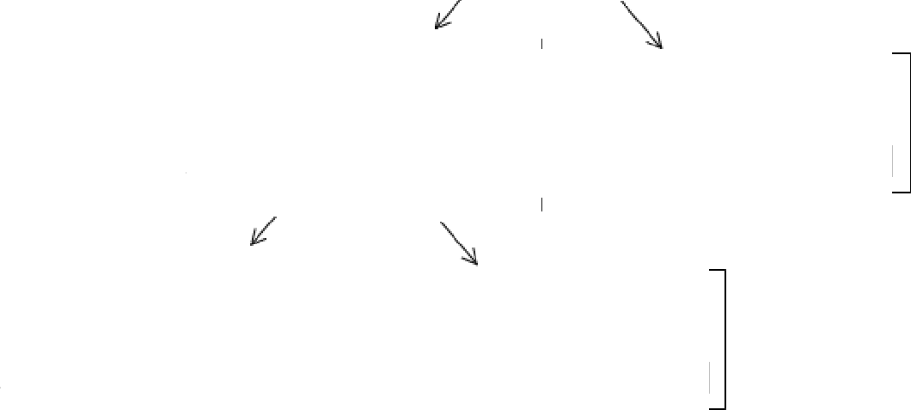

gini = 0.0

samples = 5

value = [5, 0, 0, 0]

gini = 0.0

samples = 2

value = [0, 0, 2, 0]

gini = 0.0

samples = 1

value = [0, 0, 1, 0]

X[0] <= 0.5

gini = 0.5

samples = 2

value = [0, 1, 0, 1]

X[2] <= 0.5

gini = 0.667

samples = 3

value = [0, l, l, l]

X[0] = 1.5

gini = 0.56

samples = 5

value = [0, I, 3, 1]

X[1] = 0.5

gini = 0.64

samples = 10

value = [5, 1, 3, 1]

gini = 0.0

samples = 1

value = [0, 1, 0, 0]

gini = 0.0

samples = 1

value = [0, 0, 0, 1]

y pred = model. pred1ct (X)

## from sklearn.metrics import confusion matrix from sklearn.metrics import classification report from sklearn.metrics import accuracy score

y true = y

pr1nt ( Ac c uracy : ' , accuracy score (y pred, y) )

print( '.,nConfusion Matrix: \n', confusion matrix(y true, y pred))

## matrix = classification report(y true,y pred) print( '.,nClassification report : \n',matrix)

Acc uracy : 1. e

Confusion latrix:

[[5 0 0 0j

[0 0 3 0)

[0 0 0 1)j

Classification reoort :

precision recall f1-score support

|  |  |  |  |  |
| --- | --- | --- | --- | --- |
| 0 | 1.00 | 1.00 | 1.00 |  |
| 1 | 1. *88* | 1. *88* | 1.00 | 1 |
| 2 | 1.00 | 1.00 | 1.00 | 3 |
| 3 | 1.00 | 1.00 | 1.00 | 1 |
| accuracy |  |  | 1.00 | 10 |
| macro avg | 1.00 | 1.00 | 1.00 | 10 |
| weighted avg | 1.00 | 1.00 | 1.00 | 10 |